**Starting Out with Visual Basic 2015**

**Chapter 1 Programming Challenges**

**2. Available Credit**

Step 1:

Purpose: Calculate a customer's available credit

Input: The customer's maximum amount of credit and credit used

Process: Subtract credit used from maximum amount of credit

Output: The available credit

Step 2:

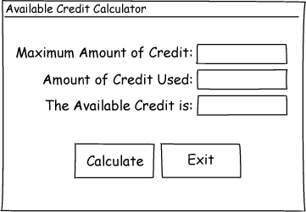

Step 3:

|  |  |
| --- | --- |
| Control Type | Name |
| Form | default |
| Label (for displaying "Maximum Amount of Credit:") | default |
| Label (for displaying "Amount of Credit Used:") | default |
| Label (for displaying "The Available Credit is:") | default |
| TextBox | txtMaxCredit |
| TextBox | txtCreditUsed |
| Label | lblAvailable |
| Button | btnCalculate |
| Button | btnExit |

Step 4:

|  |  |
| --- | --- |
| Control | Text Property |
| Form | "Available Credit Calculator" |
| Label (default name) | "Maximum Amount of Credit:" |
| Label (default name) | "Amount of Credit Used:" |
| Label (default name) | "The Available Credit is:" |
| txtMaxCredit |  |
| txtCreditUsed |  |
| lblAvailable |  |
| btnCalculate | "Calculate" |
| btnExit | "Exit" |

Step 5:

|  |  |
| --- | --- |
| Method Name | Description |
| btnCalculate_Click | Subtracts the value in txtCreditUsed.Text from the value in txtMaxCredit.Text. The result is stored in the lblAvailable control's Text property. |
| btnExit_Click | Ends the application. |

Step 6:

btnCalculate_Click

Flowchart:

Pseudocode:

Start

Subtract the value in txtCreditUsed.Text from the value in txtMaxCredit.Text, store result in lblAvailable.Text.

End

*Subtract the value in txtCreditUsed.Text from the value in txtMaxCredit.Text and store the result in lblArea.Text.*

btnExit_Click

Flowchart:

Start

End the application.

End

Pseudocode:

End